Amrita School of Computing, Amritapuri Campus.

22AIE202: Operating Systems

**LAB SHEET 2**

**Filters, Regular Expressions and Shell Programming**

Section 5 Filters

**stdin, stdout, and stderr**

The bash shell has three basic streams; it takes input from stdin (stream 0), it sends output to stdout (stream 1) and it sends error messages to stderr. The keyboard often serves as stdin, whereas stdout and stderr both go to the display. This can be confusing to new Linux users because there is no obvious way to recognize stdout from stderr.

**> stdout**

stdout can be redirected with a greater than sign. > stdout

stdout can be redirected with a greater than sign. While scanning the line, the shell will see the > sign and will create a new file and the output will be written to it.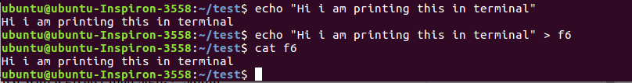

**>> append**

Use >> to append output to a file.

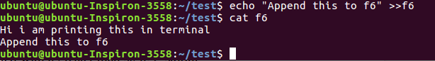

**Pipes**

Pipe is used to combine two or more commands, and in this, the output of one command acts as input to another command, and this command’s output may act as input to the next command and so on. It can also be visualized as a temporary connection between two or more commands/ programs/ processes. The command line programs that do the further processing are referred to as filters.

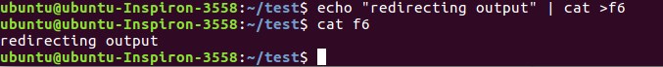

**tee**

The tee filter puts stdin on stdout and also into a file. So tee is almost the same as cat, except that it has two identical outputs.

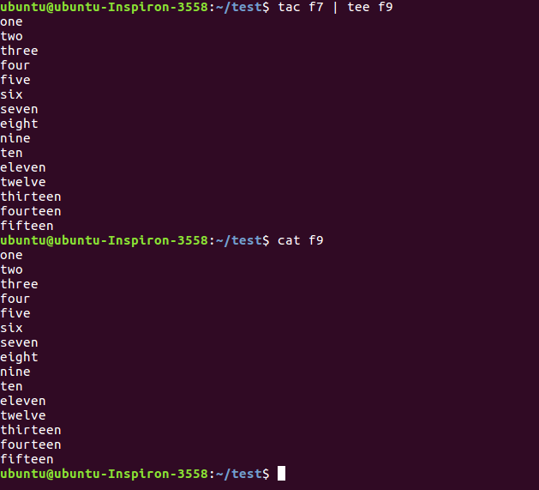

**grep**

The grep filter is famous among Unix users. The most common use of grep is to filter lines of text containing (or not containing) a certain string.

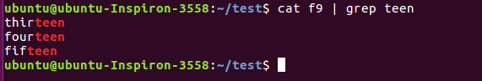

You can write this without the cat.

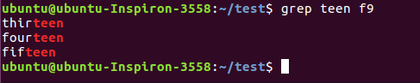

One of the most useful options of grep is grep -i which filters in a case insensitive way.

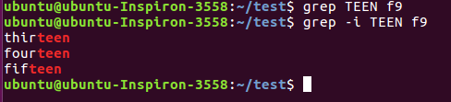

Another very useful option is grep -v which outputs lines not matching the string.

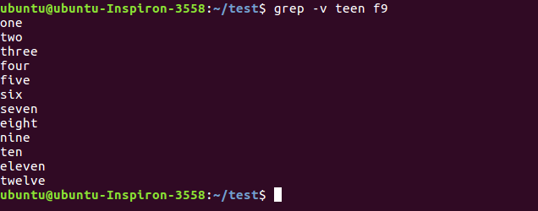

And of course, both options can be combined to filter all lines not containing a case insensitive string.

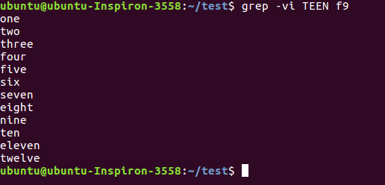

**cut**

The cut filter can select columns from files, depending on a delimiter or a count of bytes.

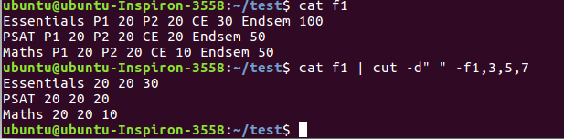

To display second to seventh character of all lines of f9

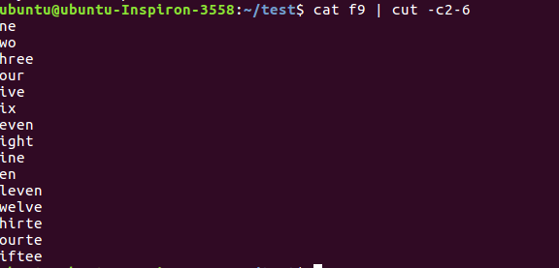

**tr**

You can translate characters with tr. The screenshot shows the translation of all occurrences of e to E.

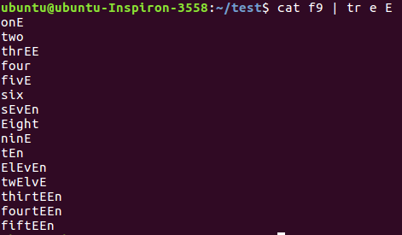

Here we set all letters to uppercase by defining two ranges.

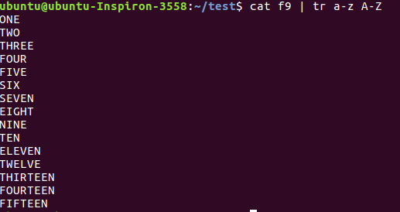

Here we translate all newlines to spaces.



This last example uses tr -d to delete characters.

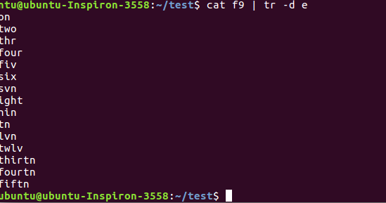

**wc**

Counting words, lines and characters is easy with wc.

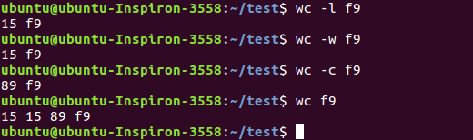

**sort**

The sort filter will default to an alphabetical sort.

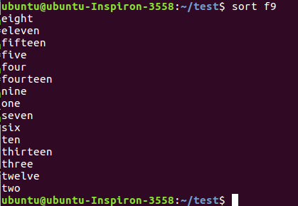

Section 6 Pipe Examples

See the examples given below and understand the working of each.

Example 1

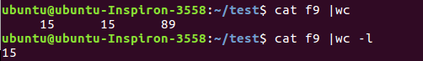

Example 2

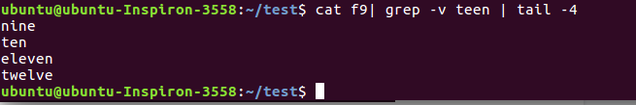

Example 3

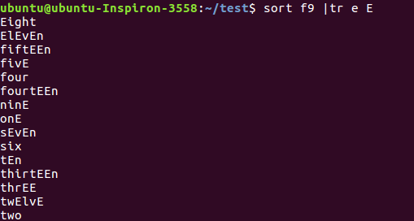

Example 4



Example 5

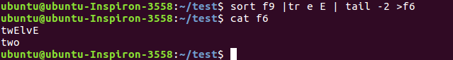

Example 6

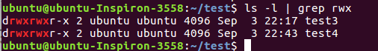

Section 7: Regular Expressions

Regular expressions are a very powerful tool in Linux. They can be used with a variety of programs like bash, vi, rename, grep, sed, and more.

This Section introduces you to the basics of regular expressions.

grep

print lines matching a pattern

grep is a popular Linux tool to search for lines that match a certain pattern. Below are some examples of the simplest regular expressions. This is the contents of the test file. This file contains three lines (or three newline characters).

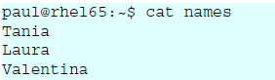

When grepping for a single character, only the lines containing that character are returned.

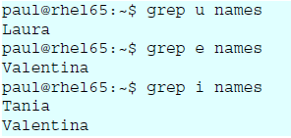

**one or the other**

Extended option in grep (-E)

In this example we grep for lines containing the letter i or the letter a.

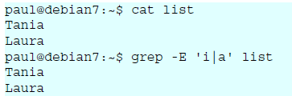

**one or more**

The * signifies zero, one or more occurences of the previous and the + signifies one or more of the previous.

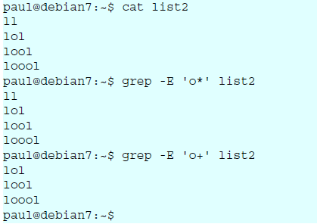

**match the start of a string**

For the following examples, we will use this file.

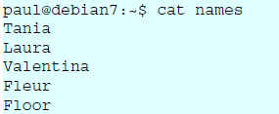

The caret character (^) will match a string at the start (or the beginning) of a line. Given the same file as above, here are two examples.

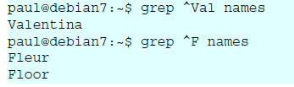

**match the end of a string**

The two examples below show how to use the dollar character to match the end of a string.

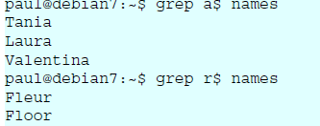

**separating words**

Regular expressions use a -w option to reference a word separator. Take for example this file:

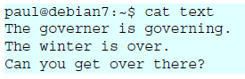

Simply grepping for over will give too many results.

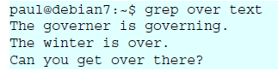

Surrounding the searched word with spaces is not a good solution (because other characters can be word separators). This screenshot below show how to use -w to find only the searched word:

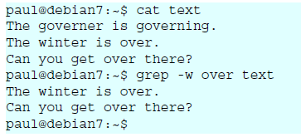

Section 8 Shell scripting introduction

Shells have support for programming constructs that can be saved as scripts. These scripts in turn then become more shell commands. Many Linux commands are scripts.

**Starting with the first shell program**

Shell scripting can be defined as a group of commands executed in sequence. The steps needed for developing shell scripts are

Step 1: Open a file with .sh extension.

gedit example.sh

Step 2: All shell scripts should begin with **#!/bin/bash** or whatever other shell you prefer. This line is called the shebang, and although it looks like a comment, it's not: it notifies the shell of the interpreter to be used for the script. The provided path must be an absolute one (you can't just use "bash", for example), and the shebang must be located on the first line of the script without any preceding space.

Step 3: Now type your actual Shell Program you want to develop and save it. (You can use the manual uploaded in lab-1 and understand the syntax for shell program).

Our first shell script will be the usual "Hello World" routine.

**#!/bin/sh**

**echo "Hello World"**

Step 4: The next step is to make the script executable by using chmod command.

Take a terminal and type

**chmod 744 example.sh**

**or**

**chmod +x example.sh**

Step 5: Now you can simply run the shell program file as

**./example.sh**

Lab Exercise

1. Create a file **demo** with the following contents

Student Alice Essentials 20 PSAT 22 Maths 34 Cultural 25 English 70

Student Bob Essentials 23 PSAT 21 Maths 32 Cultural 18 English 94

Student Boby Essentials 43 PSAT 31 Maths 22 Cultural 8 English 93

Student Clara Essentials 18 PSAT 16 Maths 27 Cultural 12 English 45

Student Dirck Essentials 25 PSAT 23 Maths 48 Cultural 25 English 98

Student Eve Essentials 8 PSAT 6 Maths 12 Cultural 13 English 5

1. Find the marks obtained by Clara in all the subjects
2. Print the marks for essentials in the increasing order
3. Find the maximum marks scored in PSAT
4. Find the minimum marks obtained in Cultural
5. Save the marks obtained by all the students in maths into a file and display it in the terminal using a single command
6. Print the first 3 letters of all student names.
7. Print the contents of file **demo** in terminal with all alphabets in capital letters.
8. Print all student names after deleting the letter ‘a’
9. Count the number of lines, words and characters in demo file after removing the letter ‘S’
10. Find the number of students with their names containing the letter a, e or i
11. Find the marks of students whose names starts with ‘b’ (case insensitive)
12. Find the names of students whose names starts with ‘b’ and ends with ‘y’ (case insensitive)

Shell Programming

1. Write a shell program to perform the following actions in the given order.
   1. Create a directory hierarchy in your home folder



* 1. Create a file file1 in directory Test3 with the contents same as output of the command ls -l
  2. Go to directory Test3
  3. Find the names of all files and folders in file1
  4. Find the names of all files and folders starting with d(case insensitive)
  5. Print all words of file1 on a separate line.
  6. Go back to your home directory.

1. Write a shell program to perform the following actions in the given order.
   1. Create a file **numericdata** with the following contents

Karunagappally 34567 7864 6785

Kollam 56754 6754 7654

Vallikkavu 54328 7548 45675

Trivandrum 16423 6654 6754

Ernakulam 28796 8549 9875

Kayamkulam 35589 75892 3451

kottayam 45557 6773 6547

tirukulum 45675 56476 7896

(Hint : First field is referred as Place second as code1 third as code2 and fourth as code3)

* 1. Display the details of Places that starts with ‘T’(case sensitive)
  2. Display code3 in sorted order(ascending) of the places that start with ‘K’(case insensitive)
  3. Filter code2 that starts with 6 and ends with 4
  4. Filter code2 having one or more occurrence of the digit 6.
  5. Filter all code1 having one or more occurrence of the digit 5.